Alaska Indoor Classroom Gardening Curriculum
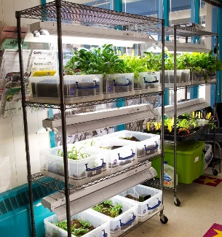
Indoor Gardening Lighting Systems Information Handout
Source: Patrick Ryan, Education Specialist, Alaska Botanical Garden
Background
The Alaska Botanical Garden (ABG), in partnership with the Anchorage School District’s 21st Century Community Learning Centers Program, an after-school enrichment program for K-8 students, has developed a system for growing plants in the schools. The purpose of the 21st CCLC is to expand learning opportunities for children and their families outside of regular school hours. These programs offer strong after-school activities, which involve both schools and the community, joining together to help kids develop into healthy adults.

Artificial lighting is a big theme in indoor growing, but you can also use natural light from a window. Plants use energy from sunlight to produce their own food and maintain essential functions. Poor lighting kills plants faster than almost any other type of deficiency. When you garden outdoors, nature does the heavy lifting for you by providing full-spectrum, diffused light. When trying to re-create that abundant light source, you have to make some practical considerations. It isn’t just a matter of choosing fixtures and bulbs that provide enough light. That would be almost as simple as picking a sunny spot in your garden to grow tomatoes! Hydroponic lamps are available in light wavelengths that approximate full-spectrum light or only certain portions of the light spectrum, typically the blues and reds preferred by plants as opposed to the greenish-yellow wavelengths human eyes are sensitive to.

ABG’s Growing Systems
The shelving and light systems ABG uses for the program are based on commercial unit, which can run upwards of $800, and quite often, shipping is not available to Alaska. Patrick Ryan, Education Specialist for ABG, has been using a homemade system in his greenhouse for several years, using old shop lights with fluorescent tubes. The big improvements with the new units are the light fixtures and bulbs. With the help of Brown’s Electric, we have designed 2 shelving units with a total of 5 light setups, 3 in one unit and 2 in the other shelf. The fixture itself is a basic T5 strip fixture with the additional Reflector added on which directs the light downward. The two lamps are the 3500 Kelvin color with is in the Red end of the spectrum and the 6500 Kelvin lamp is in the Blue end.

Types of Lighting
The type of illumination a grow light produces may be more suited to different plants or different phases in a plant’s life cycle. Cool or blue-spectrum light (430-450 nm) encourages leaf, root and stem development, while red-spectrum light (640-680 nm) enhances flowering and fruiting. Metal halide (MH) lights are popular for vegetative growth, and high pressure sodium (HPS) lights are a popular choice for the flowering cycle of most plants. Lights must be kept on a consistent schedule. A timer is a very good idea.
- Fluorescent - somewhat inefficient, must be kept close to the plants.
- LED Lights - Energy efficient, low heat output, long lasting
- HID Lights - Most cost effective, very long life
High Pressure Sodium – provides more of the red/orange spectrum for flowering and fruiting.
Metal Halide – Provides more blue/green spectrum for vegetative growth

Red and Blue spectrum bulbs:
Blue Light-This part of the spectrum is also known as cool light. These wavelengths encourage vegetative growth through strong root growth and intense photosynthesis. Blue light is often used alone during the early phases of plant growth, such as starting seedlings, when flowering is not desired.

Red Light-The longer wavelengths of light are red in color. These wavelengths encourage stem growth, flowering and fruit production, and chlorophyll production. The red wavelengths are known as warm light and they are naturally more prevalent in sunlight during the shorter days of Fall and Winter.

What are the benefits of using T5, T8, or T12 fluorescent lighting for plant growth?
- Both T5 and T12 fluorescent bulbs provide full spectrum light for optimum plant growth.
- Tere are many differences between T5, T8, and T12 lamps. The main differences are size and efficiency. For many years the only linear tube on the market was the T12 lamp. This lamp had a larger diameter than the newer technology. The number after the T in these applications relates to how many eighths the lamps have for the diameter. For example for a T12 the lamp diameter is 12/8” or 1.5”. As technology improved the T12 lamps eventually got replaced with the more efficient T8 which is a smaller 1” diameter better quality product. Another change with going to the T8 system was the utilization of an electronic ballast. T8s can run on either an instant start or rapid start ballast configuration where the T12 typically only ran on a magnetic ballast system. Prior to the appearance of LEDs in linear systems the market required a higher lumen system which resulted in the T5 tube coming into the market. This lamp is smaller than all the other lamps and typically requires new fixtures due to their shorter overall length.
- T5 fluorescent lighting is the latest in plant growth lighting. T5’s high-light output combined with its low heat and energy consumption makes it an ideal light source to grow a broader array of plants.
- T5 lamps provide the ideal spectrum for plant growth. This equates to very little wasted light energy in terms of plant growth.
- T5 lamps promote health and vigor of seedlings and cuttings. Root development is superior relative to other lighting sources. While T5 lighting is excellent for starting seeds and cuttings, it’s also able to produce enough light for full term growth.
- Because of their minimal heat output, T5 lamps can be placed 6” - 8” above the plant canopy which maximizes photosynthetic response. Unlike conventional fluorescent lamps, plants grown under T5 lamps do not have to be rotated to the center of the lamp. T5’s slim diameter enables better photo-optic control of the emitted light, increasing efficiency in the form of even light distribution.
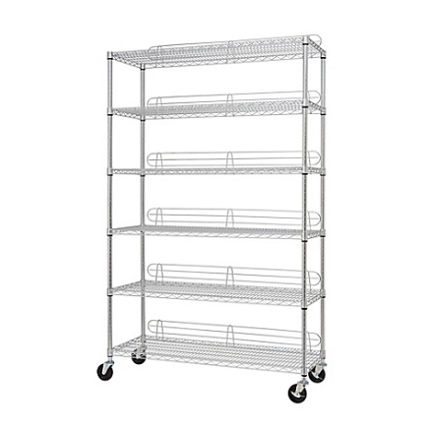
Shelving Units:
Using a tall shelf helps to utilize your vertical space. Wire shelving is great for an indoor garden because you can add, takeaway, and adjust shelves as needed.

The shelving units are available at Costco: TRINITY EcoStorage™ 6-Tier Wire Shelving Rack which measures 48” W x 72“H x 18”D and includes wheels, which can be helpful when you need to move the grow system. You can also find them at Home Depot or Lowes.

Florescent Lighting
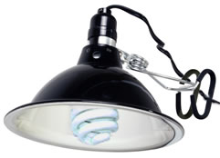

Compact Florescent

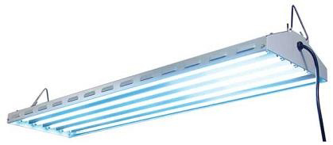

T-5 Lights in a shop light

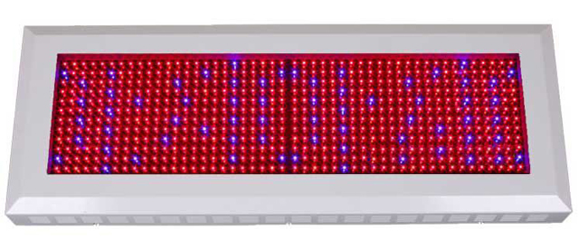
LED Lighting

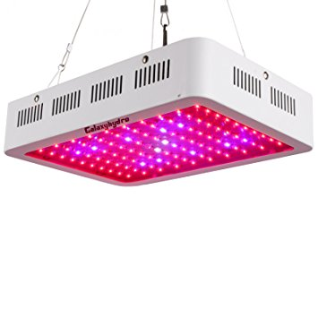

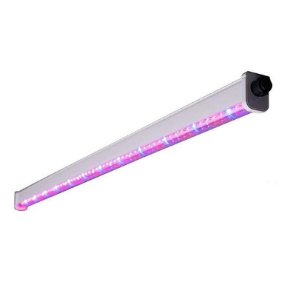

Metal Halide or High Pressure Sodium Lighting
